The Title Should be 12 to 15 Words and Should Have International Character

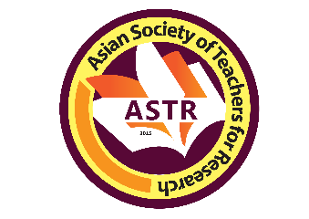

NAME OF FIRST PRESENTER
https://orcid.org/0000-0003-3068-5648
EMAIL ADDRESS
Asian Society of Teachers for Research, Inc.
Philippines

NAME OF SECOND PRESENTER (delete if none)
https://orcid.org/0000-0003-3068-5648
EMAIL ADDRESS
Asian Society of Teachers for Research, Inc.
Philippines

This is the body of the abstract. It should contain five basic parts: topic introduction, main objectives, methods, results, conclusions and recommendations (optional). The first part is topic introduction which is a one-sentence presentation of conditions that propelled the conduct of research. It is followed by the chief aim/purpose. You need to state what the study intended to discover. Do not include specific objectives in your abstract. Mention the methodology; how the study was conducted. Reflect the design, techniques, instruments (optional) and statistical treatment (optional). Next is your results; a presentation of the salient findings of your study (a sentence or two only) which leads to your conclusions which directly answers the chief purpose, your most important discovery which contributes to new knowledge, supports or negates previous conclusions, and validates the theory used. The recommendations can be reflected but optional. Crucially, the abstract must also explicitly link the research to one or more of the United Nations Sustainable Development Goals (SDGs), indicating which goals the study addresses or contributes to. Your abstract should use standard English, spelling and grammar. We will check your abstract with the Grammar software. Moreover, highlight the newness of results which are not yet in scientific literature and generates new theory. Your abstract should not be too short or too long and the word count in the body of the abstract should be 190-250 words.

Keywords: Discipline of the study, concepts studied, concepts studied, concepts studied, methods, Country

*Co-authors: NAME
AFFILIATION

